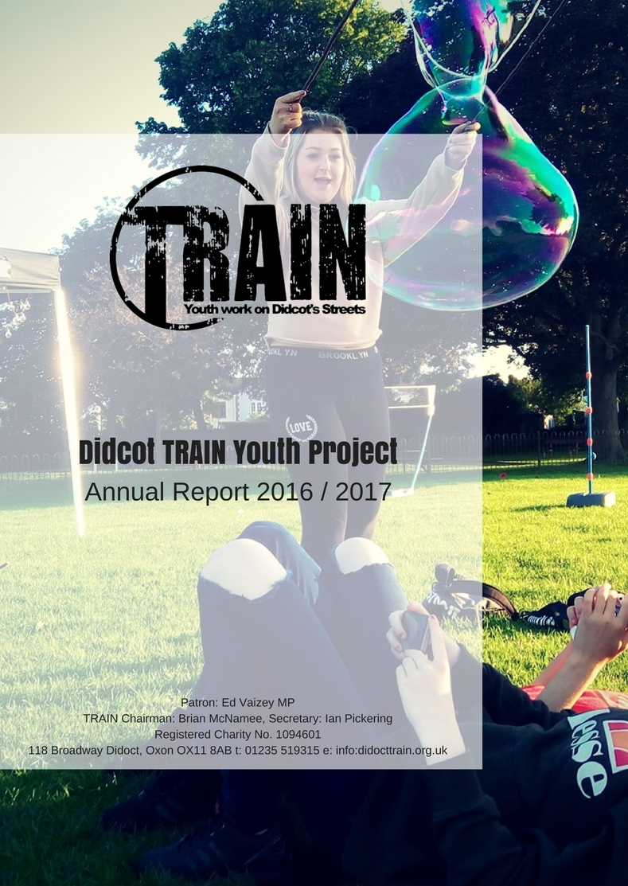

Table of Contents

Objectives and Activities 3
Chairman’s Welcome 4
Achievements and Performance 5
Lead Youth Worker’s Report 6
Introduction and Core work 6
Detached and Outreach 7
Wellbeing 8
Mentoring Case Study 10
Positive Activities 11
Investing in young people’s futures 12
Conclusion 13
Financial Review 15
Structure, governance and management 19
The structure for the past year 20

Objectives and activities
The Objects of TRAIN as recorded in the Constitution are: “to help and educate young people aged 11 to 18, who are either homeless or otherwise in necessitous circumstances, through their leisure time activities so as to develop their physical, mental and spiritual capacities that they may grow to full maturity as individuals and members of society, so that their conditions of life may be improved.”
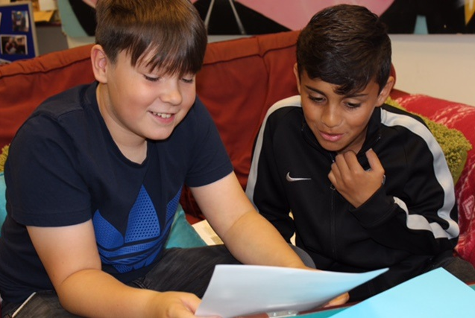
The main activities provided by TRAIN are:
- Detached and outreach in the shopping areas, streets and parks of Didcot and surrounding area. This approach reaches out to young people who are in need, disadvantaged or vulnerable. We get to know them, listen and try to understand their needs. The young people are offered support with solving problems and put in contact with others services.
- Activities that encourage young people to plan, budget and promote themselves. Recent activities have included trips and events in the school holidays to Thorpe Park and Adrenaline Alley Skate Park.
- Activities in which young people can develop their interests. TRAIN has facilitated workshops in music therapy and graffiti art for young people with whom we have built relationships.
- Physical activities that encourage learning new team and individual skills such as football training and Bubble Football.
- Mentoring young people referred by the Hub, the police and other organisations. The young people referred are those in need of early intervention to prevent them being drawn into risky situations.
- Referring young people to other appropriate organisations, such as SOFEA.
- Connecting the people, organisations and businesses of Didcot and area with the town’s disadvantaged young people.
- Engaging young people in positive activities that encourage health and wellbeing such as yoga, health day sessions, football and cooking workshops.
- Offering young people not only guidance on substance misuse but also on positive relationships in the form of our S card drop in whereby young people can access advice and guidance on sexual health, free contraception and healthy relationships.
- This year we have devised an initial 6 week programme for a group of year 6 boys in collaboration with Manor Primary School.

Chairman’s welcome and introduction
Brian McNamee
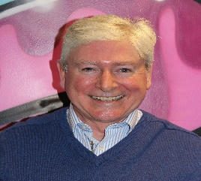
On behalf of the Board of Trustee’s I would like to express my thanks and my gratitude for all the financial support we have received from our sponsors and donors without whom we simply cannot exist. I would also like to offer my enormous appreciation for all the time effort and commitment that has been given by the Staff, Back Office and Youth Work volunteers and of course our young people to enable us to achieve our objectives.
All things considered this has been a deeply satisfying yet very challenging year. There have been some wonderful highlights to look back on which have given us great satisfaction and I would like to pick out a few of them.
It was very gratifying to receive the BACA’s Award for inspirational Youth Group at the Cornerstones in November. It was even more pleasing to experience the enormous heartfelt goodwill, support and encouragement that we seemed to receive from everyone present. It felt very special that we had so many people wanting us to do well for what they see as a most worthy cause, our young people.
Our recruitment process has been a great success and has allowed us to enormously strengthen our Youth Work capability to the extent that we now have Alice, Karo & Justina complimented by Carolina as Youth Work Facilitator. It has been terrific to have recruited such a strong team to work under Alice and even better to see their achievements with our young people.
Our own Celebration event in January was held at the Civic Hall and was a marvellous success. Our patron Ed Vaisey opened our celebrations and Steve Connel in his role as Mayor presided over the evening’s events. I would like to make special mention of Steve as he has been a wonderful supporter of TRAIN. We cannot speak highly enough of the support he gave us which even extended to spending one evening out on detached youth work but also to buying pizzas for our young people.
Immediately after the Celebration event 2 of our Young people were whisked off to their Young Leaders residential course at Milton Keynes to complete a successful double header that same weekend. Very soon after that we appointed 2 new Trustees in Laura Dennis and Luke O’Neill which was a great boost to our Youth Work expertise on the Board of Trustees.
I am very pleased to report that we were successful in winning the 4-year Operating costs grant from SODC for 2017-21. Due to the future predicted grant climate steer that all bidders received, the future funding profile is reflective of significant year on year reduction. This means that the year 4 grant is less than half of the year 1 grant which also has terms and conditions wrapped around it. It is imperative therefore that we successfully extend into new sources of sustainable funding.
In terms of my reference to challenging we met with a huge disappointment when SODC held back our grant for 2016-17 on the grounds of failing to meet our KPI’s. Given that both the changes that happened at Board of Trustee level were fundamental and the KPI’s were historically set for 2 Full Time Youth Workers you would understand my comments. Alice and her volunteers clearly punched well above their weight. We had mistakenly felt that both factors would have been a weighty consideration in the deliberations regarding releasing the grant.
I would like to express my enormous gratitude to all our sponsors and supporters for enabling us to undertake our work serving the young people of Didcot. I would especially like to thank the Community of St. John the Baptist in Begbroke and the Churches Together in Didcot collaboration. Special mention is due for the sponsorship, unwavering support, care and concern provided by:
  - All Saints Church
  - Methodist Church
  - Baptist Church
  - Ladygrove Church
  - St Peter’s Church
  - Fleet Meadow Baptist Church
Regarding our links with Didcot schools we have built upon our positive relationship with St. Birinus especially extending into mentoring programmes and with DGS. We have built a highly effective new relationship with UTC and worked on a pilot Primary School scheme in Manor School for the first time.
Finally, I would like to thank the Board of Trustees, the Staff and our Volunteers for their marvellous contribution and for all they have done over the past year.
I will leave it to Alice to explain all the wonderful work that the team have been doing with our Young People although it would be remiss of me not to thank Jack and Dom for kindly sponsoring us on their epic cycle ride from Paris to Rome – well-done guys!

Youth Work Report –Alice Dore (Lead Youth Worker)
Introduction
TRAIN has undoubtedly moved forward over the last year, with the employment of two part time youth workers.
Justina Petkunaite and Karolina Dobrzycka joined the team in the beginning of 2017, they have both brought a vast amount of experience with them to TRAIN. We have also welcomed Carolina Echegaray to the team in the new post of Youth Work Facilitator where she undertakes both strategic and youth work activities. As a result of increased staff hours we have been able to offer young people a much larger offer of provision and opportunities.
Core work
Our offer of provision has increased and we are now able to offer young people positive opportunities 5 days a week.
From March to July our programme was as follows,
Monday | Tuesday | Wednesday | Thursday | Friday
Detached and outreach | Football Project | Drop in session at the office | Detached and outreach – Skate Park | Detached and outreach
Music Project | Detached and outreach | Detached and outreach / Yoga Project
 |  | Young Ambassadors meeting

Detached and Outreach work continues to be at the core of TRAIN’s youth work, and is often where we meet the young people first. The reason the sessions are becoming more outreach oriented is that we are often encouraging young people to attend our other sessions such as football, yoga and music.

Case Study - Detached and Outreach work
Please note, the young person’s name has been changed to ensure confidentiality is upheld.
Didcot TRAIN first engaged with Jennie on detached sessions on the streets of Didcot where the team approached Jennie and the group of friends she was with and started to build a positive rapport with them over some hot chocolate. Jennie disclosed that she is going through a very difficult time at school and is school-refusing, especially with her GCSE’s only a small number of months away this was a significant cause of concern for the TRAIN team. A couple of detached sessions had occurred and a positive relationship was starting to form with Jennie and her group of friends, when Justina Petkunaite (TRAIN Youth Worker) and a TRAIN voluntary member of staff came across a serious situation whilst on a detached evening. When Justina and TRAIN’s volunteer were speaking with the young people, it emerged that there was an adult male supplying them with alcohol around the corner, Justina and TRAIN’s volunteer investigated this and saw the adult male with multiple bottles of hard alcohol such as vodka, whiskey, and two types of wine lined up next to him, with a group of young people crowding around him, some of whom were clearly intoxicated. Justina and TRAIN’s volunteer promptly called 101 to alert them in detail of what they had witnessed, this phone-call was then followed up by Justina two more times with 101 and Justina and Alice ensured they stayed with the group of young people and tried to encourage them away from the adult male with conversation and hot chocolate. It was Jennie who approached Justina and TRAIN’s volunteer to express she felt that what the adult male was doing was not right and she did not feel comfortable. This led to some very positive conversations about alcohol and the dangers of accepting alcohol from others. The fact that Jennie highlighted this behaviour negatively and felt confident to voice this was exemplary. On a subsequent detached evening with the behaviour of the adult male supplying young people with alcohol repeating, Jennie contacted the police on 101 herself and told the TRAIN team about this was again exemplary, as it further reflected Jennie’s understanding of this being inappropriate and dangerous.
Jennie then came into the office for regular meetings to discuss her attainment at school and her future prospects. Justina took Jennie along to the SOFEA project where they told her all about the alternative way of gaining experience and qualifications which Jennie liked very much and was inspired to work towards. Didcot TRAIN contacted Jennie’s school to discuss their support for her and found that the school’s attitude to Jennie’s education was in our opinion rather blasé and they said that she was intelligent enough to achieve a grade without attending school and lessons. Didcot TRAIN explored the options Jennie could be offered and also discussed SOFEA with the school. Jennie has now attended meeting with Didcot Girls School and they have put provision in place for her to have a small number of hours of teaching at the local library a day rather than Jennie having to attend school itself, this is very positive and may have a significant impact upon Jennie’s future prospects. Jennie is also engaged very positively and consistently with Didcot TRAIN, she is in the process of organising her own trip to a large trampoline park for herself and her group of friends. This involves communication skills building, budgeting and research. The team and Didcot TRAIN and feeling very positive about Jennie’s progress and participation in positive activities and the development she has made in such a short space of time.

Well-Being
Physical and mental health have been an important part of our provision to young people. We have continued to offer young people the opportunity to be a part of our football project. We were also able to offer young people Yoga workshops have been taking place over 10 weeks.
In total 19 young people participated in at least one hour of Yoga. With 7 young people attending at least 7 sessions. We were pleasantly surprised at the number of males that participated (12 males, 7 females) as we feel that yoga is stereotypically seen as a feminine practice.
13 of the young people stated that in the past week they had done no moderate intensity physical activity. Out of the 7 young people that attended regularly 6 of them stated that they had done no moderate intensity physical activity that week.
Laura from Resonate Yoga said “Yoga at Didcot Train was an incredibly positive experience for me as a yoga teacher. Students came from a variety of backgrounds and there was a high proportion of young males attending the class. All elements of the yoga class were approached with curiosity and open-mindedness from the group. They responded well to activities such as mindful walking, sun salutations, deep breathing, relaxation, balancing and partner postures. The group were inquisitive about the benefits of each phase of the class and by the end of the 10 weeks it was clear that their knowledge and understanding of yoga as a physical and mindful approach to wellbeing was well understood.”
One of the young people said “I had never done YOGA before. I have been coming to YOGA over the last 8 weeks. I have kept coming because it has been fun to learn something else.”
A young man (14) who TRAIN has met on detached and regularly smokes cannabis attend the yoga session and said “The bit at the end (relaxation) is better than smoking weed” he has said as a result when he is stressed he will do the breathing exercises instead of smoking.
A parent of one of the boys said “my son has really struggled with sleep over the past few months as there has been many incidents at school. There was a clear change after yoga sessions with him often coming home relaxed and falling to sleep before bedtime. This has also helped us at home as he is less sleep deprived“
All young people were encouraged to fill in a Warwick and Edinburgh mental health scale. 17 young people completed a survey before their first session of yoga and after their last session.

STATEMENTS | How many young people had an increase on the scale?
I’ve been feeling optimistic about the future | 9
I’ve been feeling useful | 10
I’ve been feeling relaxed | 9
I’ve been feeling interested in other people | 9
I’ve had energy to spare | 8
I’ve been dealing with problems well | 10
I’ve been thinking clearly | 13
I’ve been feeling good about myself | 13
I’ve been feeling close to other people | 11
I’ve been feeling confident | 13
I’ve been able to make up my own mind about things | 9
I’ve been feeling loved | 10
I’ve been interested in new things | 7
I’ve been feeling cheerful | 13

Overall we are incredibly pleased with the outcomes of the Yoga programme and thank Sportivate and Cath Dale for the funding. We believe that the programme has been so successful due to the relationship TRAIN youth workers have with the young people and that by holding the sessions in the office young people felt safe in an environment they are used to. We also feel that the yoga sessions were delivered by a very competent Yoga teach in Laura who has completed changed their views on the health activity and inspired them to continue.
We have continued to work with young people offering mentoring sessions and have begun to work with UTC. We were also approached by The Manor Primary School and undertook a pilot scheme to work with a group of Year 6 boys.

Manor Primary School Group- Pilot Scheme

In March 2017, TRAIN were approached by Manor Primary School to work with a group of year 6 boys who had been displaying extremely challenging behaviour from throwing chairs, smashing double glass doors and allegedly assaulting teachers and other children. I planned and prepared weekly group mentoring sessions for these young people covering a wide variety of topics ranging from managing difficult emotions, being assertive v.s. being aggressive, communication skills, and more. We saw an improvement in the majority of the boys and responded to an incident at the school by offering them more support which meant that we also carried out 1:1 sessions for the young people with great success and positive changes in their behaviour. The young people formed a strong positive rapport with the youth workers and have enjoyed a varied and exciting summer program. some of these young people have faced significant challenges in their lives over this time and we have received feedback from them regarding how much they have enjoyed their summer thanks to the work which we carried out with them. We have seen the young people displaying the skills we have encouraged them to develop on the various activities and trips we have run from improved communication skills, managing their emotions effectively and exploring their creativity.
“TRAIN have supported the school for 6months and within that time have proved themselves to be experienced, knowledgeable, understanding and compassionate. The children have enjoyed working with the TRAIN team and the group sessions proved successful, in particular for one boy, whose behaviour has changed completely because of the respect and relationships that he had with the TRAIN team. TRAIN have offered support for the leadership team at Manor school and have given their time freely to support our extra-curricular events.”
“We hope to work with TRAIN again in the future. “ Kim Rogers - Duty Head Manor School 2017.
Mentoring Case Study
“TIM” was referred for mentoring from a local secondary school. “They” had been demonstrating challenging behaviour at school for a period of time. Their behaviour at home changed from being very good to very bad, they had stolen from parents and run away from home when “grounded” previously. They had also been caught setting fires in the Didcot area and has been excluded for bringing cannabis (trace amounts) into school. They were very quick to display anger in school and has seen the school counsellor previously. “TIM” started mentoring sessions with TRAIN on the 5th December. The session focused on mental health awareness and self-esteem. After 2 sessions “TIM” was requesting support with their drug habit. “TIM” would regularly take weed, however wanted to cut down and eventually stop. TRAIN referred “TIM” to Aquarius so that he could receive specialist attention. “TIM” said that he felt safest at the TRAIN office and requested that the specific drugs work took place there and so we facilitated that. “TIM” has often come to TRAIN in times of crisis as they say “it feels really safe at the office, and I know people are trying to help me”. “TIM” had been sent home from school after being suspected of being under the influence of drugs. After an argument with their mum they did not return for 24hrs. Mum called the police to report “TIM” missing. “TIM” used TRAIN social media page to get in contact with our Lead Youth Worker Alice. “TIM” met Alice at the office and called mum to let her know they were safe. Police were then called and even though “TIM” did not want to leave the office and go home with the police, through some coaching from Alice they did. TRAIN will continued to work with “TIM” even though they have completed their 6 week mentoring program in order to help them get their life back on a positive course.
Other Case studies
Mentoring a young person* (YP) at UTC

I met this young person in June 2017, UTC had told me that they had been going through difficulties at home and that they were frequently in isolation at school due to their problems with their behaviour. My first mentoring session with this YP was an insight into the fact that they had experienced some very difficult circumstances at home, which they had not disclosed to the school, and that the YP in fact had incredibly low self-esteem. I carried out a variety of mentoring sessions aimed at exploring areas such as healthy relationships, self-esteem, managing difficult emotions, learning how to be assertive rather than aggressive, managing stress, well-being, and more. The difference to the YP’s self-esteem and confidence has been visible, they have been surer of themselves and their abilities and is much more confident in thinking about the topics we cover. Importantly, the YP has expressed how much the sessions have helped them and that they look forward to the sessions which is positive. The YP’s engagement at school has in turn improved and I have not received any information about recent disruptions which is great.

“I had some things going on at home. I want to get away from it all and it's nice to chat to you and like take my mind of it all.” The last few months have been difficult for the young person. The family of the young person is in the crisis, the young person was placed in the foster care family. Didcot TRAIN Youth Project's youth worker met the young person during detached work at the skate park. The young person keeps contact with the youth worker mostly by social media (Facebook). The young person was invited to come to the TRAIN office for a drop-in, where the young person opened up and spoke with the youth worker about their home situation, young person's fears and feelings. Over the summer we were trying to build a better relationship with the young person, involve them in the summer program and take them for some trips. TRAIN created safe space for the young person where the young person could forget for a while about family problems and enjoy adolescence. As a team we see a potential of the young person to become our young leader. Soon we are going to engage the young person in activities of the newly created group of young leaders.

Between 14th March and 20th June Didcot TRAIN Youth Project was running football sessions for young people aged 11-15. The Youth Worker responsible for football was supported by a volunteer and a young volunteer assistant.

“Well, football with Didcot TRAIN has been a fun and hands on way in which I could get involved with the practical side of youth work in a healthy way and form that many of all ages can enjoy. It has been great working with the best youth worker and a great chance to broaden my horizons.” said our young volunteer assistant. Moreover, we engaged a group of young people in doing exercise, increasing their weekly physical activity. For the majority of the group football was the first time when they had contact with TRAIN. As a result, they started following us on social media and taking part in our workshops and trips. Two young people demonstrated leadership skills and initiated a proposal for fundraising. We believe that they will soon become our young leaders and assist running activities.

Positive Activities
Trips have been a key part of TRAIN’s work over the years and I believe are still a very important piece of work that we would like to continue. With the support of the Community Safety Partnership (CSP) we were able to work with young people to plan their own positive activities holiday programme.
Monday 24th | Fifa Tournament |  | Monday 31st | GWP Family Fun Day |  | Monday 7th | Games in the Park
Tuesday 25th | Up cycle Workshop |  | Tuesday 1st | Aqua Park and Beach Trip |  | Tuesday 8th | Music Workshop
Wednesday 26th | Challenges |  | Wednesday 2nd | Art Project |  | Wednesday 9th | Go Ape Trip
Thursday 27th | Detached |  | Thursday 3rd | Detached |  | Thursday 10th | Detached
Friday 28th | Bubble Football |  | Friday 4th | Music Workshop |  | Friday 11th | Urban Garden
Monday 14th | Wellbeing Day |  | Monday 21st | Splashdown and Beach Trip |  | Monday 28th | Bank Holiday
Tuesday 15th | Oxford Ice skating Trip |  | Tuesday 22nd | Health Day |  | Tuesday 29th | Urban Garden take 2
Wednesday 16th | Cooking Workshop |  | Wednesday 23rd | Out and about in nature and practice walk |  | Wednesday 30th | Corby Trip (if money is made)
Thursday 17th | Detached |  | Thursday 24th | Detached |  | Thursday 31st | Acoustic Music Workshop
Friday 18th | Chill out in the park |  | Friday 25th | Football match |  | Friday 1st | Detached

Over the last year we have given many young people the chance to have fun outside Didcot including trips to Thorpe Park, Oxfordshire Youths Midnight Ice Skating, and Trampoline Parks. A group of young people were also keen to visit Adrenaline Alley Europe's largest urban sports venue. The three young men raised over £300 at the street fair and made it possible for 10 young people to attend in February. We have recently just completed our summer programme where we managed to offer young people prevision for something to do every week day of the summer holidays.

Investing in young people’s futures
In our mission statement we talk about how our aim is to support young people attain stability in their lives. We therefore need to invest in the young people we are working with both in time and opportunities. Where we can we are trying to ensure that young people are getting recognition for their achievements through awards and qualifications.
We have been able to send another 2 young leaders to the Oxfordshire Youth Young Leaders Programme. The Young Leaders Programme results in a Level 2 Award in Leadership and Team Skills, and is accredited by the Institute of Leadership & Management (ILM). The programme is nationally recognised, meaning that employers, colleges and universities will hold it in high regard. It’s also equivalent to an A*- C at GCSE.
We have also been recognising young people through the V Inspired; V Inspired is an independent British charity dedicated to helping young people volunteer in their local communities. Its projects are designed to engage young people who are under-represented in volunteering – for example, minority groups and those not in education, employment or training.
We are very excited to be able to recommend 7 young people to attend a residential to France in September. We will fly to France (Carcassonne) and be driven to the olive farm, where all participants are lodged in the main farm house. Mornings are spent working outside on the fields, doing light farm work. Afternoons are usually spent in the vicinity of the farm and include basic mountaineering, abseiling, canyoning, zip wire fun, scuba diving lessons, walks to the beaches, camping out and climbing Mount Canigou (2.800m). All meals are prepared by participants and are taken together. The last day of the Camp usually includes a day trip to Carcassonne before flying back to the UK.

Conclusion
The past year has seen TRAIN go from strength to strength. Below are our KPI’s from 2016/17 and our KPI’s for the first quarter of this financial year (2017/18). As you can see there has been a higher level of engagement already from employing 2 youth workers and our figures are already surpassing the ones of last year.

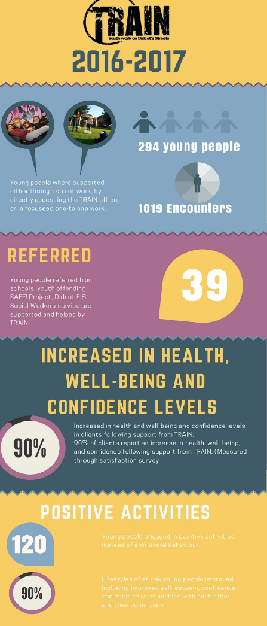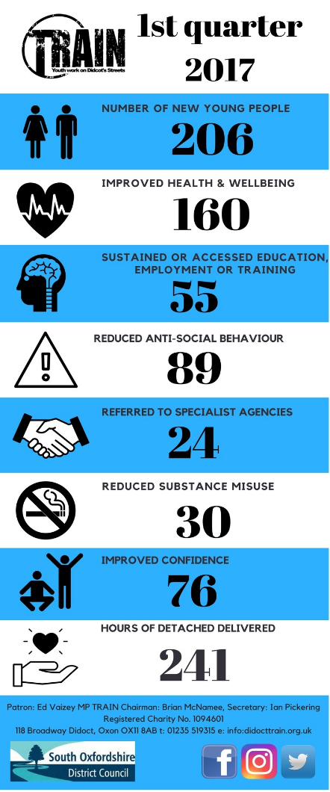

The annual celebration was a highlight as the event is TRAIN’s way of celebrating the fantastic achievements of the town’s young people, and particularly those who give so much back to the charity that helps them, as well as to the local community. Teenagers don’t always get great press however our patron Ed Vaizey MP, Steve Connel - then mayor of Didcot and a great many of the charity’s supporters came to stand alongside TRAIN’s staff and trustees and show how much the town values the contribution of its young people. For TRAIN, it’s about giving our young people the opportunities they need to flourish, and doing all they can to support our young people through whatever challenges they may be facing.
Many of TRAIN’s young people attended, with family and friends, to receive awards for achievements including Young Ambassador and Young Leader qualifications. TRAIN’s highly committed volunteer team was also celebrated. Without their selfless dedication, the charity would be unable to reach the number of young people it now manages to work with, and to give them the kind of lasting, flexible support many of our young people need.
We were also able to celebrate our BACA award when on behalf of our Young People of Didcot we picked up the Inspirational Youth Group award. There was such an outpouring of support for us from every quarter. It was uplifting to feel and made us all really proud of everyone's efforts and results!
We would like to thank a few people who have helped TRAIN over the past year. Thanks go to all the agencies that have helped in working together to ensure that the young people of Didcot have provision. To all the trustees for their tireless work behind the scenes. Most of all to the wonderful volunteers: Alice, Naomi, Lynsey-Dee, Bushra, Georg, Jon, Scott, Madhu, and Noora who is now moving across to become a trustee.I would most of all like to thank the young people. They have been a privilege to work with and we look forward to the next year.

Financial review – Carolyn Fishwick

FINANCIAL REPORT
YEAR ENDED 31 MARCH 2017
As a non-company charity with annual income of less than £250,000, TRAIN prepares its accounts using the Receipts and Payments method permitted by section 133 of the Charities Act 2011. TRAIN started the year with cash balances of £48,209 and ended it with cash balances of £38,076, a decrease of £10,133.
Income
 | £
Churches | 10,538
Grant makers | 23,039
Events | 730
Donations | 5,803
Other income | 4,294
Total Receipts | 44,404

We are grateful to our grant-makers and company donors in the year:
- Didcot Town Council
- the Community Safety Partnership
- the Community of St John the Baptist
- Didcot Rotary Club
- Thames Valley Police Property Fund
- SOHA
- South Oxfordshire District Council
- Tesco
- Pryors Taxis
- the Didcot churches:
  - All Saints Church
  - Didcot Methodist Church
  - Didcot Baptist Church
  - Ladygrove Church
  - St Peter’s Church
  - Fleet Meadow Baptist Church
We are grateful too to all our private donors, for their loyalty and generosity through another challenging year. We would also like to extend our grateful thanks to those who:
- signed up as new regular donors this year
- bought cakes and sweets off our stalls at the railway station, Christmas Street Fair, Town Fair and DGS Fest
- asked for friends and family to make donations to TRAIN in place of giving birthday presents
- bought raffle tickets at St Peter’s quiz nights
- sponsored our Secretary Ian Pickering to run a half marathon
In addition to all those who supported TRAIN financially in any other way during the year. Every penny makes a difference; £££s make even more!
TRAIN’s expenditure for the year can be analysed as follows:
 | £
Staff costs | 40,562
Youth Work costs | 5,291
Office & Utility costs | 4,229
Insurance | 818
Purchase of equipment | 1,753
Other | 1,883
Total payments | 54,536

Staff costs: We operated for 9 months of the year with a lead youth worker and a youth work facilitator, representing 1.3 full time equivalents (fte). In January 2017 an additional part-time youth worker started followed by another in February 2017, and TRAIN ended the year with 4 staff members, representing 2.3 fte.
Equipment purchased in the year included a gazebo and giant bean bags for our evening detached work, a printer and a laptop.
Excess of Payments over Receipts
TRAIN’s deficit for the year ended 31 March 2017 relates primarily to reductions in committed grants by South Oxfordshire District Council. In 2015/16 TRAIN received a grant from South Oxfordshire District Council (SODC) of £22,174. In July 2016 TRAIN received notification from SODC of its intention to retrospectively reduce the 2015/16 grant to £3,926 and offset the overpayment of £18,248 from 2015/16 against the 2016/17 grant, on the grounds that for most of 2015/16 the organisation did not deliver the core activities SODC awarded its grant to help provide. TRAIN was informed of this decision after expenditure had been committed, primarily in the form of staff and projects, and was unable to generate enough income from other sources to cover this shortfall from SODC. After 31 March 2017 TRAIN was further informed that the remaining £3,926 would not be paid over, once again after the related expenditures had been made.

In addition to cash income, TRAIN occupies its premises at 118 Broadway, leased from South Oxfordshire District Council for a peppercorn rent of £1 per year. The current lease expired on 31 December 2016 and is in the process of renewal. The value of this gift-in-kind is around £15,000 per year.
Cash balances
TRAIN’s reserves lie in its cash balances, of £38,076 at 31 March 2017. The trustees have considered what an appropriate level of cash reserves would be, to provide stability to the operation, manage the cash flow timing differences between payments for youth work and receipt of income and cover the potential gaps between the end of one source of income and the securing of another. The trustees consider a cash reserve of between 4 and 6 months’ expenses to be appropriate.
At the current scale of operations, with three youth workers, the year-end cash balance represented 5.8 months’ expenses. The trustees therefore consider the cash balance at the year-end to be appropriate for TRAIN’s needs.

Carolyn Fishwick FCA
Treasurer

Structure, governance and management

The trustees of TRAIN are responsible for overseeing the running of the charity. At 1 April 2016 TRAIN had seven trustees. At the 2016 AGM two trustees resigned (Jenny Simm and Ben Drabble) and at a special general meeting in December 2016 two new trustees were appointed (Luke O’Neil and Laura Dennis). The framework for the operation of TRAIN is set out in the Constitution. The trustees meet once a month, with additional meetings as necessary which they also double up as the Management Team alongside Alice. Individual trustees have responsibility for managing the charity’s staff, finance, governance, fund-raising, IT, premises and communications. Each individual trustee has responsibilities on which they lead. The chair of trustees oversees all aspects of the charity’s activities. During the year we have had a change in management structure with the recruitment of Justina and Karo, our new part-time youth workers, and Carolina, our Youth Work Facilitator following the resignation of our Administrator, Joanna. In the new structure Alice, as our Lead Youth Worker, is responsible for the management of our Youth Workers and Youth Work Facilitator. Laura is our trustee responsible for staff management and is the line manager for Alice. Laura consults with Brian on human resources issues as necessary.
At the AGM in 2016 a revised constitution was adopted. During the year the trustees have decided to look into setting up a Charitable Incorporated Organisation (CIO) to manage TRAIN in future. This will enable TRAIN to enter into contracts in its own right and will increase the range of organisations with which we can contract. The CIO structure will also limit the potential liability of trustees, providing trustees with more protection and making the role more attractive to future trustees. We are currently preparing an application to the Charity Commission. Under the terms of TRAIN’s constitution once the CIO has been established a special general meeting will need to be called to formalise the transfer of assets and liabilities into the new CIO and dissolve the current charity.
TRAIN’s accounts for the year ended 31 March 2017 have been independently examined by Esther Woollgar, ACA.
Public benefit statement
TRAIN’s trustees have complied with their duty to have due regard to the guidance on public benefit published by the Charity Commission in exercising their powers or duties.

The Structure for the past year
Brian McNamee Chairman
Ian Pickering Secretary
Carolyn Fishwick Treasurer
Liz Wood, Nicky Platt, Laura Dennis and Luke O’Neill Trustees.
We owe the Board of Trustees a great debt of gratitude as they have also served as the Management Team along with Alice and this has meant that they have been extremely hands on in making the charity work effectively.
Under our succession planning this year Carolyn gave us due notice that she would need to end her service at the AGM due to her career progression and work demands requiring her to change from Part Time to Full Time working. We would like to recognise the wonderful contribution she has made over her 2 years tenure.
Ian Pickering also gave us notice under the succession plan that he would potentially need to step down due to the likelihood of his Reverend wife Katherine receiving a new posting away from the Didcot Methodist Church. We are now very pleased to say that Ian will be staying with us through the coming year as the posting is not until next spring.
The structure for the 2017/18 period will therefore see us replace Carolyn with Nicole Guest and Noora Firaq, who has been an excellent volunteer supporter, will become a new Trustee with accountability for Governance. We propose to formally elect them at the AGM on 12th September and are delighted to welcome them to TRAIN’s Board of Trustees.

