Contents
Objectives and Activities 2
Chairman’s Welcome and Introduction 3
Youth Work Report 5
Introduction 5
Core work 5
Detached and Outreach Youth Work 5
Mentoring 7
Holiday Programmes 11
Investing in Young People’s Futures 12
Participation Pathway 12
Explore More Programme 14
Volunteer testimony 17
Conclusion 17
Financial review 18
Financial Report for the year ended 31 March 2020 18
Income 18
Expenditure 19
Excess of Payments over Receipts 20
Cash Balances 20
Structure, governance and management 22
Independent Review 22
Public benefit statement 22
The Structure for the past year 22
Current Trustees 22
Resignations in the Financial Period 22
Resignations after the Financial Period 23

Objectives and Activities
Didcot TRAIN - Inspiring Young People (“TRAIN”) is a Charitable Incorporated Organisation (“CIO”) registered with the Charity Commission of England and Wales under charity number 1176258. TRAIN took over the operations of its predecessor, Didcot TRAIN Youth Project (“DTYP”) in 2018.

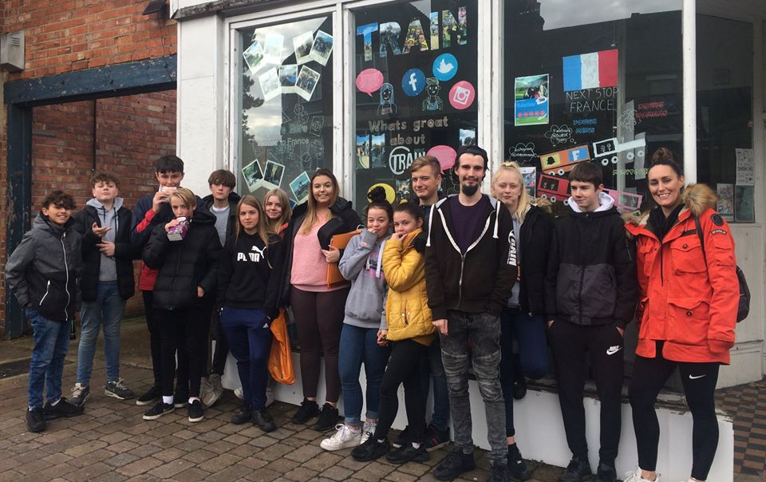

We operate within the town of Didcot, Oxfordshire and work in the gap in provision of youth services for children and young people (“YP”) who do not easily engage with mainstream provision but nevertheless are vulnerable and at high risk and are exposed to educational failure, crime, child sexual exploitation, child drug exploitation, alcohol and substance abuse, and other risky behaviours. TRAIN’s mission is to seek out, engage and empower these children and YP and improve their longer-term life chances.

Chairman’s Welcome and Introduction
I am delighted to present to you the Annual Report and Accounts of TRAIN for the year ending 31 March 2020. The year has been a challenging one: we had to move out of 118 Broadway in November 2019 and have yet to find suitable alternative premises and we had a significant amount of staff turnover, including the departure of our Director of Youth Work Services in March 2020. COVID-19 has also impacted our operations and continues to do so. Despite all the challenges, we have continued to support the development, health and emotional well-being of vulnerable young people in the Didcot area.
This is in no small part thanks to the Didcot Methodist Church who most generously allowed us to temporarily base our team at their offices whilst we searched for new premises, thus enabling us to continue our service provision. Consequently, we were able to meet our KPIs for the year ended March 2020, which is critical to us receiving our revenue grant from South Oxfordshire District Council (“SODC”). In response to the pandemic, we have moved many of our services to digital platforms so that we can continue to provide support throughout the lockdown period.
The lockdown has however impacted our service provision as we were unable to provide certain core services, such as detached, outreach and holiday trips, during this period. We also had to postpone our Annual Celebration Evening, which was scheduled for April, as well as the residential camps over the summer in France under our Explore More programme. As a proportion of our funding is linked to these service provisions, we took the decision in April to defer the replacement of our Director of Youth Work Services and to furlough one part-time Youth Worker. However, following our success in obtaining funding from [Awards for All] and PJT Partners (UK) Ltd in May, the furloughed youth worker has been able to return to work and meanwhile our Senior Youth worker is providing interim management supported by our Lead Operational Trustee.
The Board of Trustees has also undergone substantial change: as expected Ian Pickering resigned as Secretary in June 2018 as his wife, Reverend Katherine, received a new posting. Liz Wood and Noora Firaq also resigned, both for personal reasons. I would like to thank all of them for the wonderful contribution they have made to TRAIN over the last few years. Whilst the board has been augmented by the appointment of Greg Kurnikov and Maria Semmonds and is fully capable of meeting the challenges likely to be faced by TRAIN in the coming year, I believe we would be strengthened by the appointment of a trustee as Secretary. To this end, we are currently actively recruiting for this role.
On the financial side, our receipts for the period were £142,580. However, this included our Year 2 grant from SODC which was in fact due in the previous financial period. Adjusted for this, our income in 19/20 would have been £119,481, compared to a prior year pro-forma of £129,278, whilst expenditure was £123,939. Our unrestricted cash reserves at 31 March 2020 were £40,814, thus enabling us to maintain our cash reserves at just under 5 months of expenses, in line with our policy of maintaining reserves at 4 to 6 months of forecast expenses.
Finally, I would also like to express my sincere thanks and gratitude to the individuals and families who give private donations and the following supporters of TRAIN, without whom we would be unable to undertake our work serving our community and the young people of Didcot:
Angus Lawson Memorial Trust | The Good Exchange
All Saints Church | Ladygrove Church
Awards For All | PJT Partners (UK) Limited
Children in Need | SODC
The Community Safety Partnership | Soha Housing
Community of St. John the Baptist in Begbroke | Thames Valley Police Early Intervention Youth Fund
Didcot Baptist Church | Thames Valley Police Property Act Fund
Didcot Methodist Church | Willem Voorvaart
Didcot Town Council

TRAIN Chairman
Brian McNamee

Youth Work Report

Introduction
Throughout the year we operated with a team of one full-time Lead Youth Worker, several part-time Youth Workers and a full-time Youth Work Facilitator, representing 4.0 Full-Time Equivalent employees (FTEs) which was ahead of in our business plan of 3.5 FTEs. This team enabled us to once again exceed our annual KPI targets.
As well as providing our core services of detached, outreach, mentoring and holiday activities, we were again able to run our Explore More Programme, which culminated in us taking three groups of YP on residential trips to the south of France. In addition, following our success in obtaining an award from the Thames Valley Police Early Intervention Youth Fund in March 2019, we were also able to run an enhanced participation programme.
However, due to the pandemic and the resulting lockdown announced in late March, we had to suspend all of our face-to-face delivery. Where possible we moved our services to a virtual platform so that we could continue to support the YP in the Didcot area. We are currently exploring our options to recommence delivery of certain elements of our face-to-face services as the lockdown eases.

Core work
Until the lockdown prevented face-to-face interactions, we continued to make the most of the benefits offered by our core youth work streams: detached and outreach, 1:1 mentoring and group mentoring in addition to a range of positive activities.

Detached and Outreach Youth Work
Having four part time Youth Workers enabled us to expand our detached and outreach YW over the year. Our detached work involves us approaching YP in locations where they tend to spend their time across the town. Regularly going out on the streets has continued to be a core aspect of our work and particularly effective in helping us to build trusting relationships with YP.
We have especially been able to increase our outreach delivery - similar to detached but involving us setting up base at a location around the town. Informing YP where we are via social media, we give them the opportunity to come and engage with us. Setting up our gazebo and beanbags, generally in one of the local parks, has also offered a brilliant opportunity for YP to socialise in a positive environment, as well as gain advice and guidance from staff.

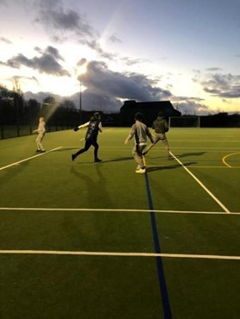  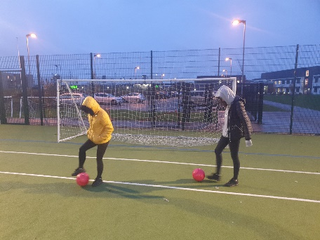 | Both forms of YW have also been particularly relevant for keeping us aware of various matters affecting YP. This has enabled us to offer targeted advice and support to YP in our weekly group mentoring sessions.  Our football sessions also continued as a particular stream of our outreach work. Highly valued by a number of YP, these were beneficial in developing skills in perseverance, self-motivation and teamwork, as well as improving the fitness level of YP and, hopefully, their footballs skills!  However, with the lowering temperatures and being a long distance from Didcot’s centre, we switched sessions to indoor fitness sessions at the Methodist Church with the onset of Winter. These were thoroughly enjoyed by a number of YP, offering a really positive release for each and a time to enjoy themselves in a safe, encouraging environment.

Case Study - Detached and Outreach work
Staff were walking through the Orchard Centre on a detached session when they were informed by one of the Centre’s Security Guards that YP were behaving anti-socially in the new Burger King restaurant. On some of them coming outside, they appeared disinterested in engaging at first. Staff however questioned if they were eating in the restaurant or whether they would like some pizza from Sainsbury’s in order to draw them away from the area.
They seemed happy when the offer was put to them so staff asked them to meet at a bench just outside the Orchard Centre, where they would bring the food. Staff were delighted to find more YP than they had initially conversed with at the spot when they arrived. This offered a brilliant opportunity for them to introduce themselves to those new to TRAIN. Some of the YP seemed shy initially, but staff urged them not to be nervous and the food helped in creating a relaxed atmosphere. With time all relaxed and began to enjoy themselves more.
Having initially noticed some of the YP chatting about fighting, staff worked to turn the conversation into one focused around empowerment through discussing pad work and its benefits in developing discipline and control, rather than for the purpose of fighting. This seemed a good way to connect with them through discussing something many could relate to. As staff were about to leave, one young person announced they would take responsibility to dispose of any litter that was left.
It was a very positive interaction overall and the YP were encouraged to come along to a new mentoring programme which began in the new year, further supporting the reduction of the recent ASB circumstances in the town.

Mentoring
We offer YP both one-to-one and group mentoring sessions and have also continued our work with local schools.

1:1 Mentoring
Throughout the year we have continued to utilise our mentoring programme as a means for supporting YP particularly likely to benefit from additional tailored support. Especially since January we experienced a clear increase in referrals from parents and schools, and we have been able to support these YP by offering them weekly sessions focused on empowering them to make better life choices, boost their levels of self-esteem and encourage them to reach their full potential. We have seen clear improvements in the mental health and behaviour of a number of YP that we have worked on a 1:1 basis this year.

Mentoring Case Study – One-to-One
Young person A comes from an extremely difficult background, including being a young carer and recently experiencing family bereavement. They indicated low levels of confidence and feelings of hopelessness in their initial assessment.
However, A engaged brilliantly in all their ALMT funded mentoring sessions. They were open and honest about their emotions and experiences, reflecting with careful consideration. Over the weeks they appeared to develop a better understanding of ways of boosting their self-esteem and generally managing their emotions in a positive way. At the programme’s end they showed a significant increase in wellbeing on the Warwick & Edinburgh scale in predominantly 9/14 areas. There was a dramatic increase in several, including thinking clearly, confidence and feeling good about themselves. Thanking me at the end of each session and commenting that they enjoyed them, further confirmed the intervention’s value.

On speaking with A following the mentoring’s completion, they appear more cheerful and stand a little taller. They assert themselves more positively than before and show a significant increase in confidence and resilience. Their attendance has been consistent at school and they have become more focused in lessons, less easily swayed into negative behaviour by others. As they work hard towards their GCSEs, they are considering the possible routes they can go into following them. It has been hugely positive to witness A’s development over the weeks. As they have been invited to attend TRAIN’s in-house group mentoring, through which they will gain opportunities to engage in youth participation and social action activities, we look forward to continuing to support them on this positive trajectory.

Group Mentoring

Young Women’s and Young Men’s Groups
These two gender specific groups have remained important in offering YP safe environments in which to enhance understandings of topics particularly relevant to their gender group. From discussions to team building and crafts, different techniques have been used to nurture knowledge and thinking, communication and awareness skills. Topics addressed and activities run are also largely influenced by the preferences of attendees. Examples of the sessions that have been delivered in these groups include:
- Using interactive website ‘Be the Judge’ to educate YP on court sentencing, by allowing YP to evaluate various crime and drug related scenarios.
- ‘Reach Out’: encouraging YP to consider the different services and individuals they can reach out to for support, writing them out onto paper hands as a regular reminder.
- Designing and pitching milkshake creations to develop creativity and problem-solving skills and boost YP’s confidence in presenting their ideas

Young Men’s Group Mentoring Case Study
On the 8 February YP regularly attending Young Men’s group took part in an art workshop ran by Tommy Watkins - a people’s choice award graffiti artist from New York. This followed from one young person’s idea for a graffiti workshop to be run. Brilliant enthusiasm for the workshop was shown by the YP coming along on a Saturday for a number of hours, where they were shown by Tommy how to use crafting knives, tools and various art techniques to design their desired stencil and create their spray paint designs. Some young people even expressed wishes that the session could have been even longer!
Whilst all created fantastic pieces, two YP seemed to gain particular value from this session. Their work stood out to both staff and Tommy and they showed an enthusiasm for more workshops in the future.
In collaboration with the Cornerstone Arts Centre, we were incredibly grateful for the opportunity for all the YP’s creations to be displayed in the Centre’s art gallery for public viewing for two weeks, alongside work from YP from Didcot Girls School. Part of this involved an opening night for the work in which the artist attended along with some TRAIN staff, Trustees and volunteers.
It was very special for the YP to see their work on display in the gallery and all expressed a desire to be able to keep their work after the exhibition had ended. We were hugely thankful to Tommy, the Cornerstone and Oxford based social enterprise RAW for enabling the workshop and exhibition to come about and following the success of the project, hope to work to deliver more in the future!

Dinner & Debate
Dinner and Debate has also continued to be a successful aspect of our provision. Overarching aims and topics correspond to those for Young Women’s and Young Men’s, but more typically addressed through group discussions or debates. Mid-way through YP head to our local Greggs the Bakers, who generously provides us with fresh food at the end of their business day, to collect donated food which can be enjoyed communally during continued discussions.

Dinner & Debate Group Mentoring Case Study
C began attending Dinner and Debate Sessions in the latter half of 2019 and has come to build particularly strong rapport with staff. C is intelligent but struggles with their mental health and would regularly behave antisocially at school, their behaviour largely being influenced by their anxieties and low mood.
Since attending, both staff and C’s family have observed clear improvements in their behaviour. This includes being removed from lessons considerably less. They have made more positive friendship choices, no longer spending as much time in town amongst YP who tended to have a negative influence on them. They have also demonstrated a better understanding of their own wellbeing and recognised when they need to take time for themself.
The group environment of the sessions and staff’s approach in encouraging respect between attendees for one another’s inputs during discussions has been valuable in improving C’s general listening and communication skills. Previously frequently speaking over others, the team have observed a clear reduction in this tendency and they generally now contribute very well. This includes bringing their own experiences into conversation and how they have dealt with personal issues.
Since joining the group, they have demonstrated an extreme eagerness to get involved wherever they can at TRAIN, including one occasion where they opted to fundraise with us rather than going out with their friends, turning up very early eager to help!
The YP has expressed to us that they see TRAIN as a safe space for them to go, especially appreciating talking to Youth Workers and having admitted that the sessions always lift their mood. Their development since first attending Dinner and Debate has been hugely rewarding to see and they have clearly greatly valued the social, positive environment the sessions have offered. Throughout the lockdown since March this year, staff have been continuing to reach out to them each week to ensure they can maintain the trusting relationship they have developed with them over the months, support them throughout the uncertainties of the times and encourage them to remain focused on their positive aspirations for their future.

Head Start Programme
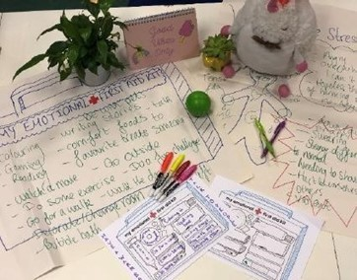  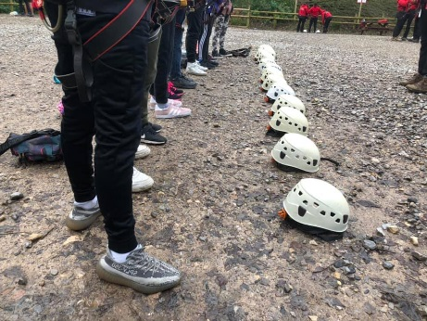 | Our Head Start programme was launched last year and is an early intervention programme offering group mentoring sessions to Year 6 11-year olds at local primary schools. This programme is supported by the Angus Lawson Memorial Trust, who assessed our Year 1 performance on the 3-year grant and determined that they would continue to fund the programme for another year.  Each programme comprises six sessions focused on either: Promoting Wellbeing and Exploring Mental Health, Positive Behaviour in School, Team Building and Self-Esteem. This also contributes towards building an effective transition into secondary school.

Holiday Programmes
We have organised a schedule of activities, trips and workshops for YP during each of the school holidays prior to lockdown.
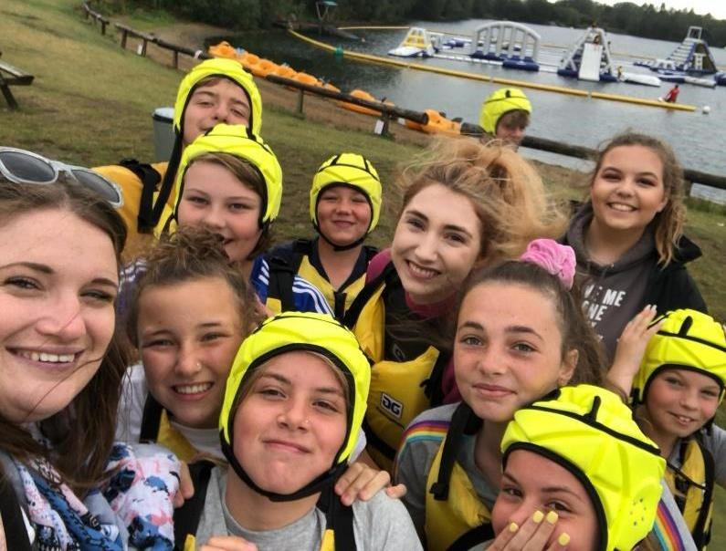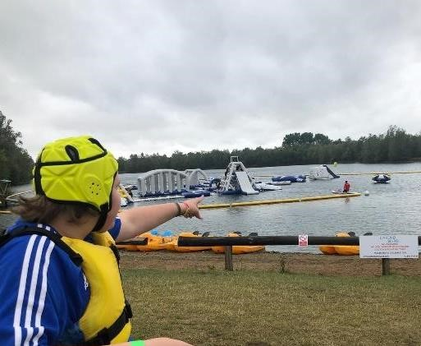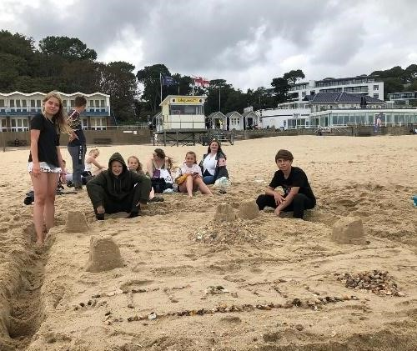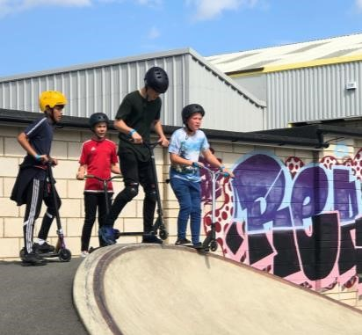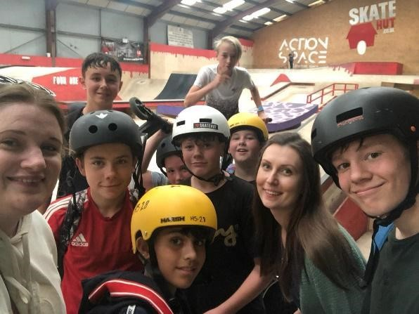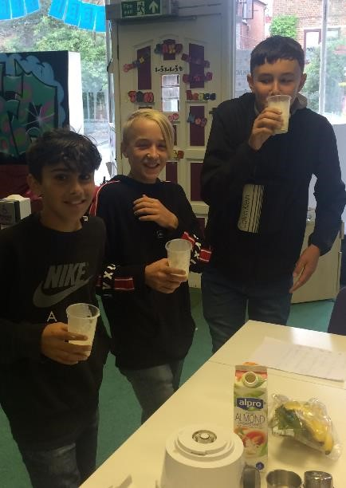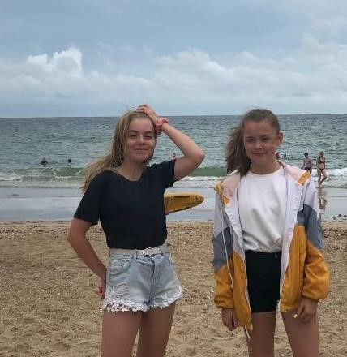

Through offering a variety of activities, we have aimed to support YP attending in developing a range of useful life skills, deterring many from anti-social behaviour they may otherwise be likely to be drawn into and also simply providing them with opportunities to have fun and enjoy themselves.
Examples of activities carried out this year include trips to Oxford Crazy Golf, Aqua Park, Adrenaline Alley, Splashdown, Poole, Bournemouth Beach, the cinema and bowling and Rush Trampoline Park. We also arranged several workshops including Josh Newman’s ‘Fearless’, smoothie-making and photography.

Investing in Young People’s Futures
In order to help YP attain stability in their lives, we have continued to invest in the futures of the YP we are working with throughout the year. This has often involved giving YP opportunities to gain recognition for their achievements through awards and qualifications.

Participation Pathway
Our youth participation work also remains an important aspect of our delivery. Our Youth Workers have been working with a number of YP engaged on our Participation Pathway, which gives YP the opportunity to gain greater responsibility and influence TRAIN’s work by engaging with us at a variety of different strategic levels:
- Young Volunteers: YP that are at the beginning of their additional engagement with TRAIN and wish to offer their time to support the young ambassadors and young leaders at events.
- Young Leaders: YP who take a leadership role in planning and delivering events, trips and local social action projects to benefit other young people and their community.
- Young Ambassadors: YP are engaged at a strategic level and represent TRAIN and other young people at local community and regional meetings, as well as interviewing volunteers and staff.

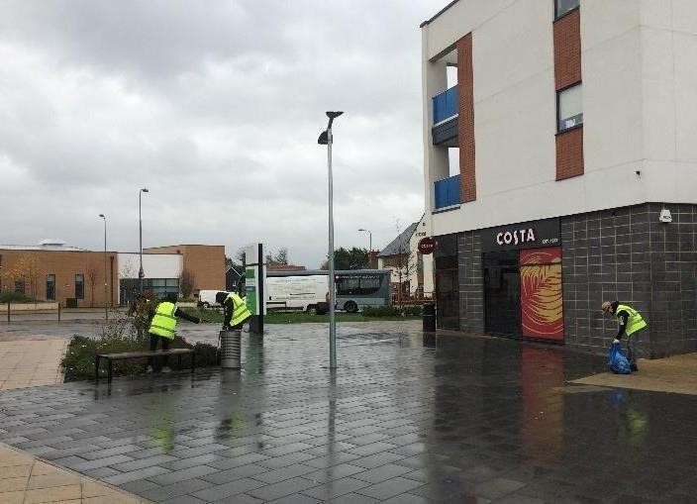 | YP engaged on the Pathway have taken huge pride in their roles. The opportunities offered act as a clear demonstration to YP of positive ways in which they can engage in their local community and the enjoyment which can be gained from such interactions. Community and fundraising projects undertaken in the year include:  - Fundraising at Didcot’s Tesco store  - Holding a tombola at Didcot Street Fair  - Taking part in Didcot Town Council’s October Litter Pick
As well as encouraging the YP engaged on the Pathway themselves to continue exercising positive behaviours, by acting as positive role models they have also been seen to positively influence their peers. Being highly valued by YP engaging at TRAIN, the Pathway thereby continues to act as a valuable stream of our provision for incentivising YP to engage and make positive choices.

Case Study
E, who first became known to TRAIN in Summer 2018, initially struggled with extremely low self-esteem. Despite their clear positive development since engaging in TRAIN mentoring sessions, as they were still presenting signs of insecurity and at times poor behaviour, in 2019 the Youth Work team decided it would be beneficial to award E the title of TRAIN Young Leader. As well as rewarding them for the fantastic personal growth demonstrated over previous months, staff also felt the title would offer a constructive means through which to continue building the young person’s confidence and particularly skills in leadership and organisation.
E displayed fantastic enthusiasm for the title and began to increasingly offer ideas and opinions on how to run sessions as well as an eagerness to help in running them. As a result, they have often led initial ‘check-in’ discussions in group mentoring sessions, whereby each young person is given the opportunity to discuss their days. They also did a brilliant job leading a main activity, staff not feeling a need to intervene at all throughout considering their enthusiasm and control.
Observing the excitement and value E gained from the role, over the following months it was decided to progress them up the Participation Pathway’s ladder of responsibility to become a TRAIN Ambassador. This has seen them become more activity involved in supporting fundraising efforts and social action projects, including a litter pick and fundraising at Didcot’s Tesco store. In the latter event they appeared to thoroughly enjoy representing TRAIN and were pro-active in talking to members of the community. Afterwards they expressed an interest in doing another Tesco fundraiser, but instead spending a whole weekend day there. Staff reported that the event helped further improve their confidence, as well as giving them a chance to show the community that the YP of Didcot can act in a positive way both socially and professionally.
The young person’s positive attitude has been fantastic to see and we have been continuing to work with them to support them in continuing to make positive choices and progressing along this path of positive development.

Explore More Programme
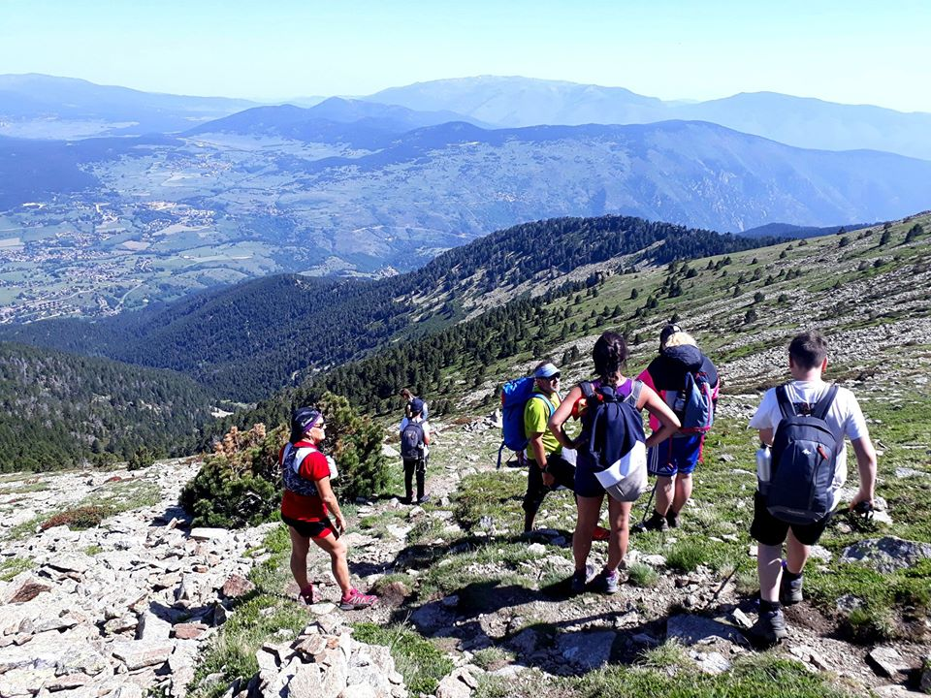
Explore More is an intensive personal development programme which culminates in YP attending a residential camp in the south of France. These residentials are made possible by the philanthropy of Mr Voorvaart, a Dutch entrepreneur and olive farmer, who generously hosts the YP at his olive farm, covers our transport, food and accommodation costs and provides a programme of activities with trained guides.
21 YP participated in the programme this year across three trips – an increase on previous years. This included a new Level 2 programme for five YP who had completed the programme in previous years.
Designed to develop crucial life skills and inspire young people to return with renewed motivation for their futures, each week-long camp proved to be successes in multiple respects. It is clear certain YP thrived on the experience, developing renewed motivation and self-respect to channel into their behaviours and decision-making on their returns.
Although there were understandably wobbles throughout, the experience had clear transformational impacts on a number of the YP who took part, with really quite incredible positive changes being reflected in behaviours and attitudes throughout the course of each week.
After the exciting first flight ever for many of the YP, meeting the team at the farm and the all-important bonding session with the many beautiful dogs, it was not long till each group were getting stuck into the programme’s adventures. Across the trips these included 2-day mountain hikes, mountain running, canyoning and diving board jumping. All the YP should be extremely proud of all they achieved.
Each YP’s positive motto for the week, chosen on Day 1, proved important for many in encouraging their motivations to push themselves. Group mentoring sessions were also held throughout to encourage the teams to reflect on their accomplishments each day, during which all nominated a peer to be awarded a medal for their achievements. This mutual support proved really important in bringing each team together.
Particularly impressive attitudes were also demonstrated by many towards farm work undertaken each week as part of the Level 1 programme - log chucking for Camp 1, or self-named Team FAM (Fun, Amazing Memories), and stone picking for Team POP (Positive, Outgoing, Perseverance). Being clearly quite laboursome, repetitive tasks, it was brilliant to hear how high levels of engagement often were throughout the work, with little moaning. Some even showed excitement to get stuck in, despite the 7am starts!
Being immersed in the French countryside, visiting the local town and trying home-cooked French cuisine each night, the cultural and environmental appreciation many gained from the trips was also particularly admirable, embracing their surroundings and circumstances with hugely respectful and often childlike appreciation. The emergency packet noodles were not once resorted to!
After heading out there with both excitement but also clear apprehension for the unexpectedness of the experience, the teams returned with an array of really quite magical memories to inspire them in their everyday lives back home. We have been continuing to work with the YP since to remind them of the personal progress each made throughout the programme and motivate them towards continuing this development in shaping bright futures for themselves.
We are incredibly grateful for the support of all who played a role in the planning, organisation and delivery of this Summer’s trips, as well as keeping things going back in Didcot in the meantime.
Following Camp 1 we interviewed a couple of the YP who took part, whose responses clearly show the huge value they took from the experience:
How did you feel when you were offered the opportunity to go to France?
“Gobsmacked!”
“Scared but excited because I knew I would never get the opportunity again”
How did you end up finding the whole experience? Was it different to what you expected?
“Way different – not sure what expected but found the experience amazing”
What was the most important thing you took from the trip?
“Didn’t think I’d make mountain – felt happy when I achieved it!”
“A new sense of responsibilities”
Do you think the things you took from the trip have changed you in any way now you’re back?
“Yes - can now open up more to other people and rather than saying I can’t do things, now know that I can”
“Yes – behaviour, overall respect”
On a scale of 1-10 how much did you enjoy France? (1- not at all 10 - loved it)
Scores of 10 and 11/10!

Mr Voorvaart, also described the week as: “probably one of the best Camps we have had in the past 7 years”. Despite Mr Voorvaart’s generosity, we incur substantial expenditure in arranging these trips as we need to ensure that the young people have the correct documentation and equipment and are adequately insured. Youth Worker staffing costs for the trips are also high due to the intensity of the programme and the number of staff required.
We are therefore grateful to the organisations who supported our 2019 trips including: The Good Exchange, Oxfordshire Community Foundation, Pye Charitable Settlement and the Turners Court Youth Trust.

Volunteer testimony

Darren and I moved to Didcot in 2015. I noticed the TRAIN premises practically straight away and thought that was an organisation I would like to know more about. However, we were very busy, looking for a house, renovating it, building an extension, developing the garden. By the time we had more time it was 2018. I noticed there was a volunteering fair in Didcot so I suggested we went along to see what we could get involved in. We met Justina at the fair who suggested we visit the TRAIN website and complete a volunteering application. We were contacted by Carolina, the volunteer coordinator, went in for a chat, got our DBS’s done and the rest is history. Volunteering for TRAIN is fun, worthwhile, gratifying, challenging and amazing. The young people are wonderful and it feels so good when we’re recognised and accepted. We continue to develop our skills working closely with the youth workers. TRAIN is expanding and we will be with them all the way for many years to come.

Rhonda Wilson, 2019

Conclusion
This year has again been one of continued progress for TRAIN. Through the combined efforts of our staff, trustees, volunteers, young people and stakeholders, we have been able to increase our youth work provision throughout the year and thereby improve the life opportunities of an increasing number of YP.
However, the current Covid-19 pandemic has resulted in all face-to-face deliver being paused for the time being. To prevent the circumstances negatively impacting the rapport built with YP and to ensure we are continuing to offer positive opportunities to the YP throughout this unusual period in time, our entire programme has been transferred to virtual platforms but we look forward to re-establishing our face-to-face service once the lockdown eases.
We would like to thank all who have supported TRAIN’s youth work throughout the year, including all the trustees for their incredible hard work, the amazing volunteers for their inspiring degree of support and of course all the YP who have been a privilege to work with and for whom we look forward to seeing continue develop and flourish.

Youth Work Facilitator Senior Youth Worker
Charlotte Jenkins Justina Hodson

Financial review

Financial Report for the year ended 31 March 2020
As a CIO with annual income of less than £250,000, TRAIN prepares its accounts using the Receipts and Payments method permitted by section 133 of the Charities Act 2011. TRAIN started the year with cash balances of £49,395 and ended it with cash balances of £67,506, an increase of £18,111.

Income
 | 19/20  £ | 18/19  £
Churches | 7,814 | 9,365
Grant makers | 118,255 | 57,840
Events | 177 | 230
Donations | 10,833 | 10,738
Other income | 5,501 | 7,050
Total Receipts Before Transfer from DTYP | 142,580 | 85,223
Transfer from DTYP | - | 50,255
Total Receipts | 142,580 | 135,478
We are grateful to our grant-makers and company donors in the year:
- Angus Lawson Memorial Trust
- Children in Need
- the Community Safety Partnership
- the Community of St John the Baptist
- the Didcot churches:
  - All Saints Church
  - Didcot Methodist Church
  - Didcot Baptist Church
  - Ladygrove Church
- Didcot Town Council
- Mountain Warehouse
- SODC
- Soha Housing
- Thames Valley Police (Early Intervention Youth and Police Property Act Funds)
- The Good Exchange
We are also grateful to all our private donors, for their continued loyalty and generosity. In particular, we would like to extend our grateful thanks to the following:
- All our regular donors
- Mr Voorvaart for enabling us to offer young people the opportunity of attending international residentials at his camp in France and
- Everyone who bought raffle tickets at St Peter’s quiz night

Expenditure
TRAIN’s expenditure for the period can be analysed as follows:
 | 19/20  £ | 18/19  £
Staff Costs | 101,980 | 61,573
Building and Services Costs | 6,993 | 5,505
Supplies and Consumables | 2,765 | 3,201
Insurance | 1,285 | 1,070
Project costs (incl. Residential trips) | 10,486 | 14,151
Purchase of Fixed Assets | 430 | 584
Total payments | 123,939 | 86,084

Staff costs: Throughout the year we operated with a full-time Director of Youth Work Services and a full-time Youth Work Facilitator and the equivalent of two full-time Youth Workers, representing 4.0 FTEs. Last year we operated with an average of 2.7 FTEs.
Building & Services costs: These primarily reflect electricity and telephony costs, which are paid quarterly in arrears, and rental costs of 118 Broadway which we leased from SODC under a tenancy at will.
Supplies & Consumables: These primarily reflect stationery, printing, website and subscription costs. As our Celebration Event was unfortunately postponed, costs for this event are not included in the current year unlike the prior year.
Project costs: This reflects the cash costs we incur relating to our detached and outreach work, holiday activities, mentoring and international residential trips organised for young people under our Explore More Programme. The actual value of these trips considerably exceeds this amount as the cost of our accommodation, food and activities is most generously covered by Mr Voorvaart. Project costs were lower in the current financial year primarily because the residential trips scheduled for Summer 2020 have been cancelled as a result of the COVID-19 crisis.
Fixed Asset Purchases: Four mobile phones were purchased in the year.

Excess of Payments over Receipts
TRAIN had a surplus for the year ended 31 March 2020 of £18,641. This surplus was the result of SODC paying us both our second and third year grant monies, of £23,099 and £18,099 respectively, in the current financial year. The delay in the second year grant payment was due to a delay in novating the grant from the Didcot TRAIN Youth Project to TRAIN. Adjusted for payment, we would have had a deficit of £4,458 in the current financial year.

Cash Balances
TRAIN’s reserves lie in its unrestricted cash balances of £41,417 at 31 March 2020. The trustees have considered what an appropriate level of cash reserves would be, to provide stability to the operation, manage the cash flow timing differences between payments for youth work and receipts of income and cover the potential gaps between the end of one source of income and the securing of another. The trustees consider a cash reserve of between 4 and 6 months of expenses to be appropriate.
At the current scale of operations, with 3.4 FTEs as of 1 April 2020, the year-end unrestricted cash balance represented just under 5 months of expenses. The trustees therefore consider the cash balance at the year-end to be appropriate for TRAIN’s needs.
Nicole Guest ACA CFA
Treasurer

Structure, governance and management
The trustees of TRAIN are responsible for overseeing the running of the charity. The framework for the operation of TRAIN is set out in its Constitution dated 14 July 2020. The trustees hold a monthly meeting, with additional meetings as necessary, as they also double up as the management team. Individual trustees have responsibility for managing the charity’s staff, finance, governance, fundraising, IT, premises and communications. Each individual trustee has responsibilities on which they lead. The chair of the trustees oversees all aspects of the charity’s activities.
Justina, our Senior Youth Worker, is currently responsible for the direct management of our Youth Workers and Youth Work Facilitator. Justina reports to an Operations trustee, Maria Semmonds, who is responsible for overall staff management.

Independent Review
TRAIN’s accounts for the year ended 31 March 2020 have been independently examined by Esther Woollgar, ACA.

Public benefit statement
TRAIN’s trustees have complied with their duty to have due regard to the guidance on public benefit published by the Charity Commission in exercising their powers or duties.

The Structure for the past year

Current Trustees
Brian McNamee (Chairman)
Nicole Guest
Greg Kurnikov (Appointed 14 May 2019)
Luke O’Neil
Maria Semmonds (Appointed 13 August 2019)

Resignations in the Financial Period
Noora Firaq (Resigned 10 May 2019)
Nicky Platt (Resigned 10 December 2019)

Resignations after the Financial Period
James Seddon (Appointed 11 February 2020; Resigned 7 June 2020)

Calculated as the income before the transfer of net assets from DTYP of £85,233 plus DTYP’s income for the period ending 29 March 2019 plus the year 2 grant from SODC

