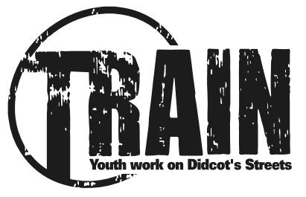
118 Broadway,
Didcot,
OXON, OX11 8AB
E: justina@didcottrain.org.uk
T: 01235 519315 – www.didcottrain.org.uk

Young Person’s Self-Referral for Mentoring with TRAIN

1. YOUR DETAILS: All Information will be treated as confidential

Date of referral:

Your Name(s): Parent/Carer’s Name:
Address: Post code:
Telephone No:(Home): (Mobile):
Date of Birth:
Parent/Carer Contact No: Name of school/College:

2. INFORMATION ABOUT YOU:
a) Do you have other professionals working with you either at the moment or who have done in the past? E.g. CAMHS, Social Care, Yellow Sub, TAB or YOS (if yes, please put who they are and when they were working with you)

b) Are you struggling with any of the areas below at the moment? – please tick all that apply to you.

􀂉 Substance misuse 􀂉 Was struggling with school 􀂉 Feeling Low

􀂉 Feeling Anxious 􀂉 Finding friendships difficult 􀂉 Involved in Criminal justice system

􀂉 Family problems 􀂉 Finding emotions/ behaviour difficult 􀂉 Finding School targets difficult to meet

c) Health Information and any formal diagnosis e.g. ADHD, mental health (if relevant):

3. REASON FOR REFERRAL:
Why would you like to have Mentoring?

In which areas do you feel you would most like to have mentoring support with (e.g.: Goal setting, school attendance, anger, friendships and relationships, self-esteem, mental health etc.?)

Additional notes or information that you think will benefit the referral:

Signature of young person: ……………...…............................................................. Date:………………

OFFICE USE

