**Dear all,**

Welcome to our first newsletter in a little while, the last few months have been extremely busy at Didcot TRAIN with lots going on!

# **Non Term Time Fun!.**

With Lockdowns easing and more freedom to get back to our normal work, we were able to offer the young people who engage with TRAIN lots of opportunities to get involved with trips, activities etc.

**Positive Activity Trips**

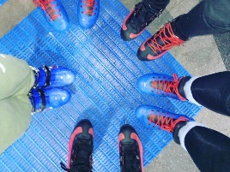Over the summer we took advantage of this newfound freedom and embarked on several days out with our young people. Firstly, we took the train to Oxford and went Ice skating. This is a firm favourite of our young people! This trip gave those who were more confident on the ice the opportunity to show their skills. But also support others in the group who was experiencing this for the first time. (Norris even went Ice Skating!)

We also took the young people bowling. Another trip to Oxford and the Hollywood bowl, where the young people also took the opportunity to spend some time in the arcade too, even breaking the high score record on the basketball machines.

The following week the young people tested their golfing skills at ‘Junkyard Golf’ in Oxford. The funky lights and the challenge of putting the ball through cars and down slides, was an unusual golf experience. But not unusual at Junkyard Golf! And there was plenty of hole in ones had!

During the October half term another favourite of the young people was a trip to Thorpe Parks famous ‘Fright Night’. With scary rides and spooky mazes, the young people had the opportunity to explore the park with their friends and take advantage Halloween themed activities. For many of our young people this was their first trip to Thorpe Park. An excellent reward for engaging positively with TRAIN throughout the year!

**Activities**

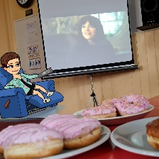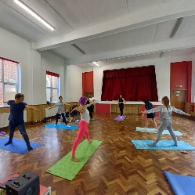During the summer we also hosted several activities and sessions in Didcot. Firstly, we had Rachel (a friend of Lucinda’s!) come along to the Didcot Methodist Church and do Yoga Rave workshops! This is not your normal calming and peaceful yoga; this is yoga with a rave twist! With loud energetic music playing the young people could practice new skills and movements. Lucinda also hosted a movie and doughnut night! The young people came along and got comfortable on the bean bags and watched the new ‘Cruella’ film.

Other activities we provided over the term time breaks were ‘Bollywood Dancing’ with our new youth worker Honor! Honor is an enthusiastic Bhangra dancer and taught the young people a few routines.

**Outreach**

Throughout the last few months, our team of youth workers were ever present in the town via our outreach session and detached youth work. It was great to see many of our young people and new young people at our Outreach sessions at Edmond’s Park. These A table with food on it
outreach sessions were an opportunity for young people to come along and sit on picnic blankets, play some sport, and have a few snacks and drinks. These outreach sessions included a session right before the summer holidays at Didcot Girls School. It was great to meet many young people at DGS whilst on their lunch break and tell them about what TRAIN had coming up. This is something we hope to do again soon and at other schools in the town.

# A grill**End of Summer BBQ Celebration**

Due to the pandemic at TRAIN we had been unable to have our annual celebration since 2019. So, to ensure we recognised the young people’s efforts and engagement during such challenging times, we planned an ‘End of Summer BBQ Celebration’. This Hawaiian themed event we hosted at our new Youth Club home on Great Western Park. We saw families and young people attend the event, with lots of food, activities and awards handed out. This was an excellent opportunity to invite families and show off the amazing things the young people had been doing, as well as invite and engage new young people. We would like to say a massive thank you to SOHA for sponsoring the event and all those who attended. We look forward to doing something special this year, to celebrate 20years of Didcot TRAIN!!!

# **Head start**

Our in-school group and 1:1 mentoring programme Head start has been busy, since the schools returned in the September. Lucinda has been working hard with all the towns secondary schools to offer this unique support to students. The young people can engage with sessions from Health and Wellbeing, Positive Relationships, How food effects mood etc. With 1:1 work being a safe space for young people to share their concerns and worries with the support of our youth workers. As part of the process of positively engaging with the programme the young people celebrate completing this 6-week programme with positive team activities. Most recently we visited Didcot ‘Escape room’. With the young people working together to find clues and solve puzzles the young people successfully escaped the room with 10minutes to spare!

# **Shout! LBGTQ+ Group- *New\***

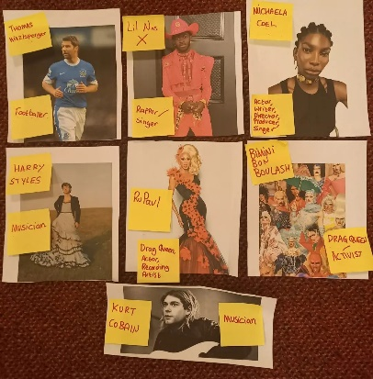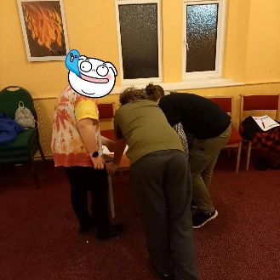Didcot TRAIN are pleased to announce the start of their new Shout! LBGTQ+ group. Shout is our new LGBTQ+ and questioning young person’s group. It is a safe space to connect, socialise and have fun with other LGBTQ+ Young people! So far, the group have been positively discussing words and phrases used to describe people’s identities and role models etc. This safe and open space for young people to be themselves has already got a lot of attention! On Friday 28th January, Lucinda was invited onto the Kat Orman show on BBC Radio Oxford. Lucinda spoke about this new group starting up and there has been great interest from young people already. To hear Lucinda on BBC Radio Oxofrd check out our website. [www.didcottrain.org.uk/2022/01/31/lucinda-on-bbc-radio-oxford/](http://www.didcottrain.org.uk/2022/01/31/lucinda-on-bbc-radio-oxford/) This month Lucinda will be looking at 50years of Pride and this month is ‘LGBTQ History Month’. So there will be lots to share in our next newsletter.

**Dinner and Debate**

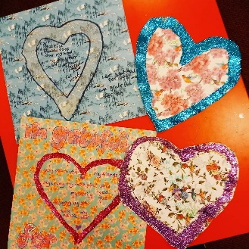Our new youth worker Honor has been busy with her new Year 7&8 Dinner and Debate group. Since starting this new group, Honor has involved the young people with planning topics and themes to discuss. The young people have raised topics of which they wish to understand more and explore. Honor has been extremely happy with the way the group have come together and grown in confidence, with the support of our volunteer Emma. The young people have been engaging with positive games and activities to help their learning, online technology such as Kahoot! Quizzes have been used to engage the young people with topics such as, Black history month, Climate change and mental health challenges. Our dinner and debate sessions for year nine and older covers a wide range of topics relevant to their age group. Recently we have been covering topics, such as body image, self-esteem, healthy relationships, and mental wellbeing. Along with fun A picture containing person
activities promoting teamwork and communication (like our spaghetti and marshmallow tower challenge).

**Youth Club**

**Our youth club sessions are an open access provision split into two different age groups (year seven and eight, year nine and older) in which young people can talk to youth workers, have somewhere fun and safe to hang out or make use of the facilities (table tennis, board games, music and karaoke machine, arts and crafts, ps4 and gaming, snacks, hot chocolate and more). Over the last few months youth club has also had a wide range of themes including movie night, sushi making, takeaway and games nights.

**Participation**

During the October half term, Lucinda and her participation group completed a 10mile round sponsored walk to Abingdon and back. This sponsored walk was in support of PICU, PICU is a charity support babies and their families whilst in intensive care units. This charity was chosen as it is close to the heart of a young person attending our sessions. The group of young people raised £110! Well done to them all!

# **Christmas Carols & Ladygrove Christmas Event**

Just before Christmas, the Hagbourne Community Choir contacted Didcot TRAIN about supporting us at their up coming Carol Concert outside Sainsburys in the Orchard Centre. Spreading the festive cheer, the community choir invited TRAIN staff and young people to join them and collect donations from passers-by. With the young people holding collection buckets and explaining the work Didcot TRAIN do, £105.10 was collected. We would like to thank Hagbourne Community Choir for choosing Didcot TRAIN as their charity to collect for this year!

Also, we would like to say a massive ‘Thank You!’ to the Ladygrove residents association. Before Christmas they hosted an event in the car park of Didcot Town FC. The event saw a selection of festive themed stools, as well more Christmas carols being sung. The Ladygrove Residents Association chose Didcot TRAIN as the charity they were supporting. We are extremely grateful for the efforts as over £600 was raised at this event.

# **Other News**

Continuing with our introductions to the team here at TRAIN.

 Spotlight On…

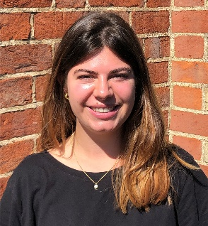

**Honor**

Hi, my name is Honor, and I am one of the youth workers at Didcot TRAIN. I have a breadth of experience of working with young people in the charity sector and am passionate about ensuring young people have access to opportunities, despite the challenges they may face. Previously, I worked for the educational charity, Project Trust, which provides Gap Year opportunities to young people aged 17-25.

I am also a Research Assistant at the Universities of Kent and Oxford, supporting Dr Martha Newson with her research on how football clubs can help tackle reoffending. I am keen to draw on my experience as a Research Assistant, as well as my degree in Social Sciences (Social Anthropology), to inform my practise as a youth worker at TRAIN.

On Tuesdays, I support our other youth worker, Charlotte P, to run the youth club. This gives the young people we work with a safe space to meet and engage in positive activities, reducing the potential risks they might face if they were on the streets. On Wednesdays, I lead the Dinner and Debate session for Year 7 & 8’s. In this session, we discuss topics that the young people feel are important to them, for example, body image, bullying and online safety. I also go out on Detached with one of our Volunteers on Wednesday evenings. This unique way of working enables us to build trusting relationships with the young people we engage with, interacting with them in places where they feel most comfortable.

**This coming month and keeping updated:**

This month we are pleased to have our half term timetable, this includes trips, outreach and special themed sessions at Youth Club and Dinner & Debate. Please see the timetable below.All updates to our provision can be found at [www.didcottrain.org.uk/covid-19-provision-update](http://www.didcottrain.org.uk/covid-19-provision-update)

**Know a Young Person who wants to get** **involved?**

Do you know a young person aged 11-18 years living in Didcot, Harwell and/or attending a Didcot school who would like to get involved? Please direct them to our social media pages or our [website](https://www.didcottrain.org.uk/) where young people can keep in the know about what sessions the Youth Work team are offering day-to-day and get involved in any virtual activities by following/friending their TRAIN social media accounts. Our Weekly Timetable can also be found on all platforms towards the beginning of each week.

Young people are very welcome to message staff’s Facebook and Instagram or call/message their work numbers in their delivery hours 🡪

**Thank You:**

As always, we are extremely grateful to all those who support us, we could not continue our work without you. We would particularly like to thank:

* **Didcot Methodist Church** for still allowing us a room in their premises and providing the young people with a safe place to meet.
* **TRAIN’s Trustees** for working hard to enable us to continue providing the provision we do.
* **Teachers and support staff** as you prepare again to welcome the young people back into the classroom.
* **TRAIN’s volunteers,** your continued support each week has a positive impact on the lives of the young people we work with.
* **All the young people** who continue to engage with us and the young people who have recently come to TRAIN.

**Special Thanks to all our funders!**

The last couple of years have been strange and challenging for everyone. But having such understanding and flexible funders, we have been able to adapt the support we offer young people. So, from Didcot TRAIN and their young people, we would like to a say massive thank you to:

* Angus Lawson Memorial Trust
* Children in Need
* Community Safety Partnership
* PJT Partners
* Didcot Rotary Club
* Garfield Western
* Oxfordshire Community Foundation
* National Lottery Awards for All
* Thames Valley Police
* SOHA Housing
* Sovereign Housing Trust
* Didcot Freemasons
* Society of the Holy Child Jesus
* South Oxfordshire District Council
* Turners Court Youth Trust
* Pye Charitable Settlement
* Oxfordshire Community Foundation
* Tesco Didcot
* Didcot Churches- All Saints, Methodist Church, Baptist Church, Ladygrove Church
* District Councillors- David Rouane, Victoria Haval, Mocky Khan
* Williem Voorvaart
* Didcot Town Council
* Private Personal Donors-Ben Drabble, Jenifer Loder, Mr. Polehampton FP& AJ Snell, D Riddell

**Ways to support TRAIN:**

As mentioned above, we appreciate all support hugely. A few ways in which you may be able to help:

**Spread the word!**

One of the biggest ways to help is simply spreading the word! From talking about what we do with others, to sharing our Facebook, Twitter and TikTok posts (@DidcotTRAIN), this all helps us reach as many young people as we can in the area.

**Amazon Smile:**

Make a free donation every time you shop via Amazon Smile - you can choose Didcot TRAIN Inspiring Young People as your chosen charitable organisation and a percentage of your order value will be donated when you shop through [Amazon Smile](https://smile.amazon.co.uk/), at no cost to you whatsoever!

**Donations/Fundraising:**

We’re incredibly grateful for donations of any size. As a small charity, these donations directly support our ability to offer a diverse range of activities to benefit the development of young people’s self-esteem, life skills and motivations for their futures. More information on making a single or regular donation, or fundraising for TRAIN [can be found here](https://www.didcottrain.org.uk/donate).

**SO Charitable Lottery:**

Tickets for the weekly [lottery](https://www.socharitable.co.uk/) cost £1, each with a 1 in 50 chance of winning a prize of up to as much as £25,000! From every £1 ticket, 60p goes to the registered cause of your choice and another 10p then distributed to other good causes in South Oxfordshire. Good luck!

**Thank you for reading**

We hope that you have enjoyed reading about the fun we had over the last few months. We really appreciate your support as the services we provide are helping so many young people to live their best life and fulfil their potential. As things continue to improve nationally it remains a very challenging time for young people and we look forward to telling you about how we have continued to support them in our next newsletter.

If you would like to receive email notifications of our news updates, please head to the bottom of our [website’s](https://www.didcottrain.org.uk) homepage for the sign-up link or get in touch with us through one of the means in the footer.A group of people posing for a photo

**Best wishes,**

**The TRAIN Team**